JENKINS - CHALLENGES – 02
==============================================================

Title
Parameterized Jenkins Pipeline for SIMPLECUSTOMERAPP
Objective
To create a parameterized Jenkins Pipeline job that allows users to:
- Select a Git branch at build time
- Choose a target environment (dev or qa)
- Execute a complete CI pipeline including Checkout, Build, Test, and Package stages
- Display build status clearly based on the selected environment
Prerequisites
- Jenkins installed and running
- Pipeline plugin enabled
- Git installed on Jenkins server/agent
- Maven installed and configured
- GitHub repository accessible from Jenkins
- Java configured on Jenkins agent
- Proper network access between Jenkins and GitHub

Conclusion
This setup successfully demonstrates a parameterized Jenkins Pipeline where:
- Builds are flexible and reusable
- Branch and environment selection happens at runtime
- CI stages execute in proper sequence
- Build results are clearly visible and environment-specific
This approach improves automation, control, and clarity in CI pipelines and is ideal for real-world DevOps workflows involving multiple environments

QUESTION: Create a Declarative Jenkins parameterized pipeline for simplecustomerapp.

Step 1: Create New Pipeline Job
- Open Jenkins dashboard
- Click New Item
- Enter job name: SIMPLECUSTOMERAPP-parameter_job
- Select Pipeline
- Click OK

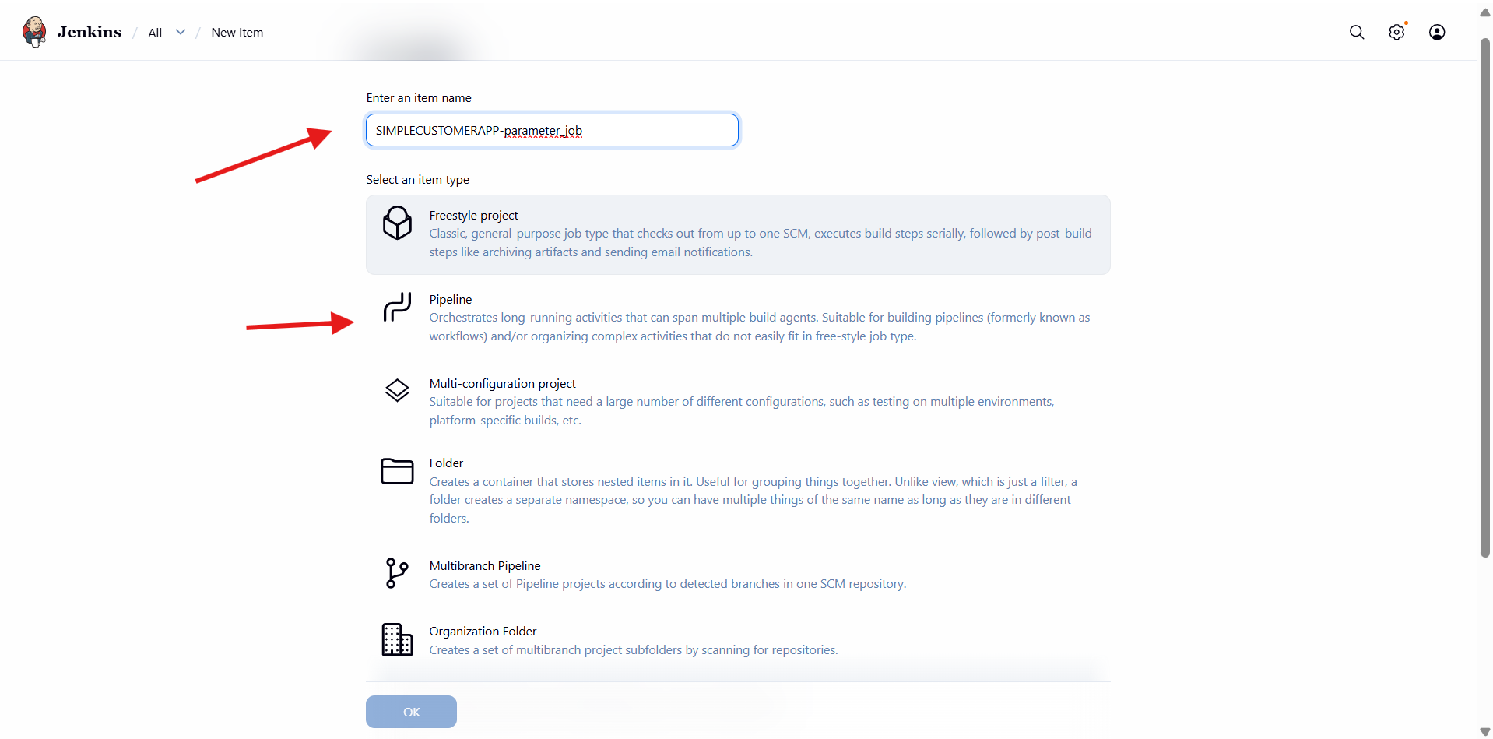

Step 2: Enable Parameters
- Go to Configure
- Under General, enable This project is parameterized
Step 3: Add Choice Parameter (ENV)
- Click Add Parameter
- Select Choice Parameter
- Name: ENV
- Choices:
- dev
- qa
- Description: Target environment

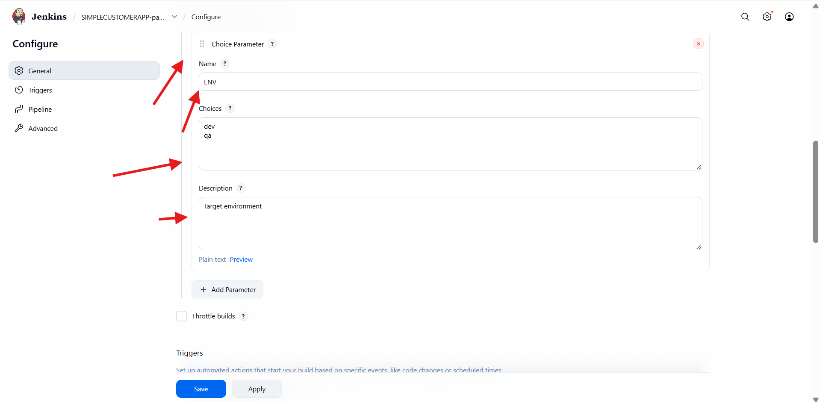
Step 4: Configure Pipeline Script
- Go to Pipeline section
- Select Definition → Pipeline script
- Paste the pipeline code containing:
  - parameters block
  - BRANCH_NAME (string parameter)
  - ENV (choice parameter)
  - Environment variables
  - Stages: Checkout, Build, Test, Package
  - Post actions (success & failure)

Step 5: Define Parameters in Script
- Add parameters inside pipeline:
  - BRANCH_NAME with default master
  - ENV with choices dev, qa
Step 6: Configure Environment Variables
- Set:
  - APP_NAME
  - MAVEN_HOME
  - Update PATH with Maven binaries
Step 7: Checkout Source Code
- Use Git repository URL
- Checkout branch using:
- ${params.BRANCH_NAME}

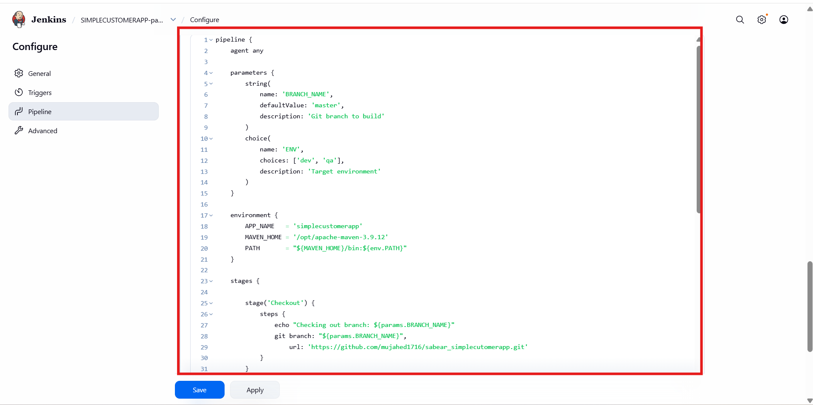
Step 8: Build Stage
- Run Maven command:
mvn clean compile
Step 9: Test Stage
- Execute:
- mvn test

Step 10: Package Stage
- Execute:
- mvn package

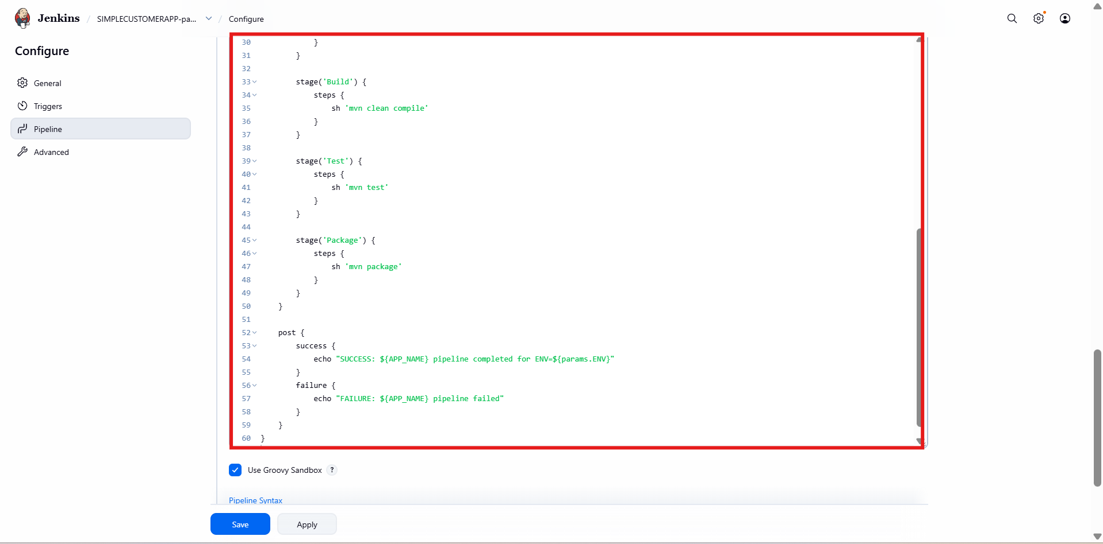
Step 11: Configure Post Actions
- On success:
  - Print success message
  - Include selected environment
- On failure:
  - Print failure message
  - Mark build as failed

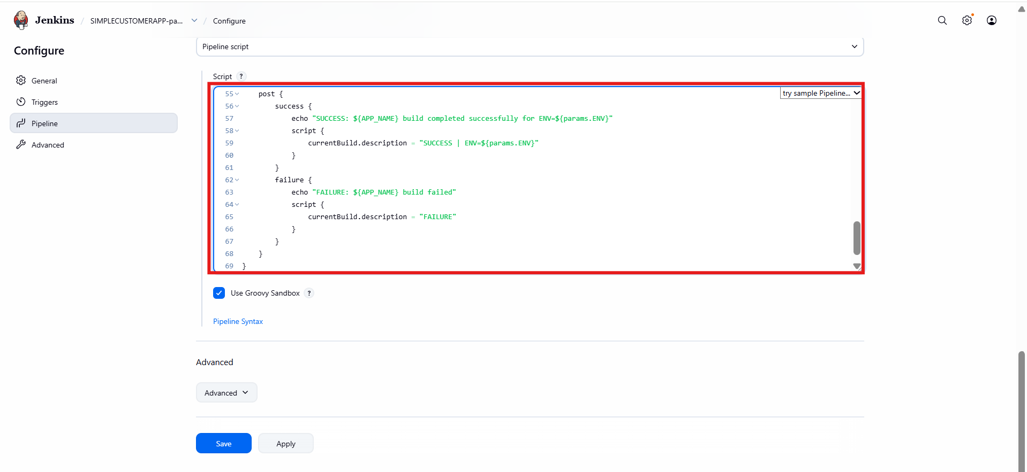
Step 12: Trigger Build with Parameters
- Click Build with Parameters
- Select:
  - BRANCH_NAME (default: master)
  - ENV → dev or qa
- Click Build

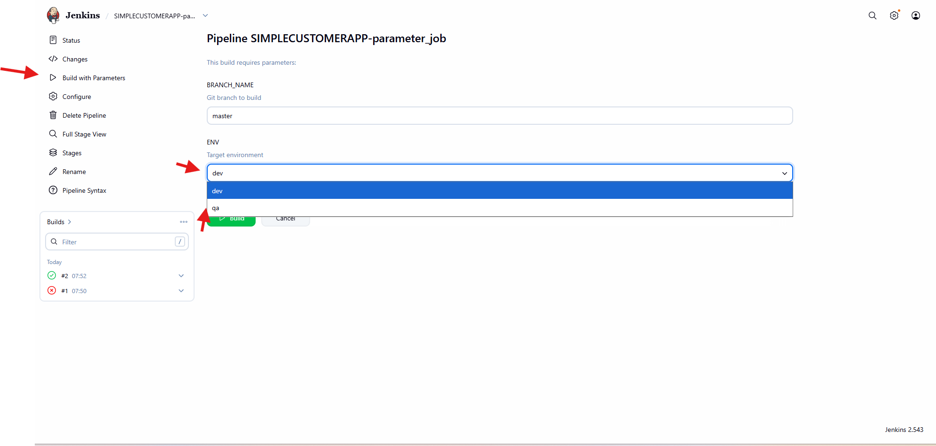
Step 13: Verify Stage View
- Open Stage View
- Verify stages:
  - Checkout
  - Build
  - Test
  - Package
  - Post Actions
- Confirm build status is SUCCESS

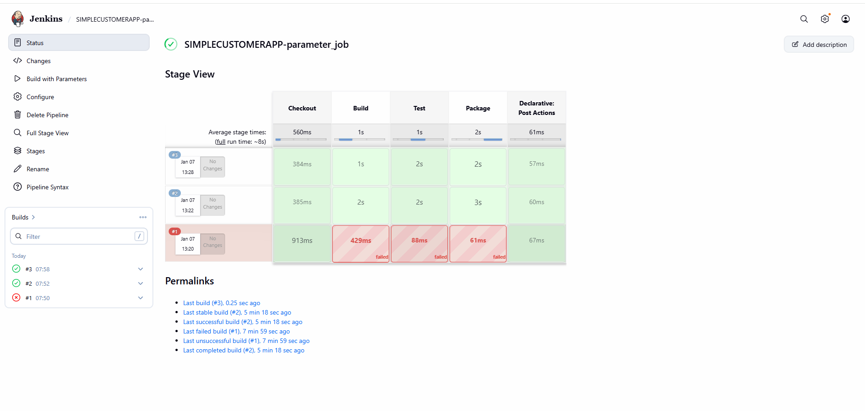
Step 14: Verify Build Description
- Open build details
- Confirm description shows:
SUCCESS | ENV=dev (or qa)

